|  |  |  |  |
| --- | --- | --- | --- |
| Technical NoteTN739CF-PVDF - High temperature transient injection analysis | | | |
| Subject | Assessment of a high temperature transient analysis for Equinor | | |
|  | Name: | Date: | Signature: |
| Prepared by: | J Latto | 13/07/2021 |  |
| Checked: | A Paternoster | 13/07/2021 |  |
| Technical approval: | H de Boer | 13/07/2021 |  |

## Summary

The objective of this Technical Note (TN) is to illustrate the Technology and Manufacturing readiness level (TRL & MRL) of Strohm CFPVDF TCP in relation to the BMC33 2” MEG line application. This application will be referred to as the ‘target application’ within the remainder of this document.

It is understood that the target level of TRL 4 is to be demonstrated in order for Strohm to be considered in Equinor’s supplier assessment for the target application which will be carried out in October 2021.

In summary, the assessment shows that the requested application, considering the specifics of the bore fluid operational and transient ‘load cases’ is within the capabilities and qualification scope of the current Strohm CFPVDF jumper and flowline qualification program and that this program is currently at TRL4 and MRL level 9 respectively.

## Reference documents

| **RD** | **Document name / number** | **Rev.** | **Description** | **Security class** |
| --- | --- | --- | --- | --- |
|  | DNVGL-ST-F119 | Aug ‘18 | Thermoplastic Composite Pipe | N/A |
|  | AOGTN721 | Jul ‘20 | Overview of TCP Qualification Status | A |
|  | AOGTN730 | Feb ‘20 | Representative Fluid Selection Based on Solubility Parameter | A |

Document security class:

N/A: Not applicable

A: Available under current NDA agreement

RR: Restricted Review - available for review in Strohm data room only (Strohm premises)

## Target application requirements

The target application can be summarized as a MEG injection line with incidental high temperature hydrocarbon excursions. The application conditions are listed below and have been assessed to determine if the overall pipe performance is affected by the transient events and if these can be repeated across the entire lifetime of the TCP

Application details:

Length - 150m (subsea pallet deployed)

Internal Diameter - 2”

Service life - 25 years

Water Depth - 2880 m

Water Temperature - 4 °C

Pressure Rating - 4,570 psi (315 Bar) normal, 4,350 – 7,250 psi (300-500 Bar) operating range, 10,000 psi (690Bar) max

Fluid Requirements - Continuous operation MEG (90% wt.) with high temperature HC excursions

**For the assessment of the target application, a conservative fluid ‘load case’ has been assumed:**

* **Normal service will be MEG exposure at 90%, 50 °C and 690bar**
* **12 annual HC excursions of 100% Toluene, 130 °C and 690 Bar**

## Strohm CFPVDF TCP readiness levels

Qualification of Strohm TCP is carried out in accordance with DNV Standard DNV-ST-F119 (RD-01) and is broken down into three key pillars for overall qualification evidence and certification. These pillars are at the core of Strohm TCP and are intended to provide a modular approach to design and manufacture of TCP to a high, repeatable standard.

These pillars can be broken down as follows:

1. Materials – Fit for purpose and qualified materials matched to application
2. Design – Generic design methodology that can be applied to all TCP
3. Manufacturing – Type approved manufacturing equipment, facilities and quality assurance

In addition, for each discreet pipe system, a product or ‘target application’ level qualification is also needed. This aspect brings together the base level Design and Manufacturing qualifications with a specific, fit for purpose material selection in order to validate that the combination results in a delivered system that is certified by DNV for the intended application.

To date, Strohm have a significant track record in supplying qualified TCP for intervention, jumper and flowline applications using both EGFPE as well as CFPA12 material systems. This track record includes the full DNV qualification of the TCP design methodology, manufacturing type approval as well as specific material system qualifications.

Strohm’s TCP qualification status and track record is provided for reference in technical note TN721 – Overview of TCP Qualification Status (RD-02). This document provides an overview of the TCP qualification status, its relevant track record and material & pipe testing. The document also aims to provide an insight into the relation between testing and the design methodology laid out in DNVGL-ST-F119 (RD-01) on Thermoplastic Composite Pipes (TCP).

There are two key measures used to show the maturity of a product, the Technology Readiness Level (TRL) and Manufacturing Readiness Level (MRL). Note: The API TRL scale and the US DOD MRL scale are widely accepted and have therefore been used in this assessment.

With regard to EGFPE systems, Strohm are fully qualified and have attained a TRL level of 7 and MRL level of 10. This indicates a fully qualified product with operational track record along with a mature and optimised manufacturing process. As the approach to the design and manufacture of TCP is modular, it is necessary break down this assessment with regard to CFPVDF systems as follows:



### Material Qualification CFPVDF system

In terms of material qualification, Strohm have completed all required work for the CFPVDF system utilising the following materials:

* Liner Material - Arkema Kynar 400 PVDF
* Laminate Material - Solvay Evolite F3050 CFPVDF Tape
* Coating Material - Solvay Solef 6012 PVDF

This includes a comprehensive testing and validation program. A summary of the testing carried out for these materials can also be found in AOGTN 721 (RD-02).

In line with the Strohm TCP design methodology and by using a combination of analytical tools and DNV endorsed representative fluid methodology described in AOGTN730 Representative Fluid Selection Based on Solubility Parameter (RD-03), it is possible to assess a new application using the materials data obtained during qualification.

The target application assessment is detailed further from section 1.5 of this technical note.

### Product design and validation

Extensive development has been carried out in the past years on the design, prototyping and performance validation of CF PVDF pipe systems. These systems consist of the same base materials as the target application and share the same design process and prototype production recipes. Currently, Strohm is engaged in a joint project with Total and Exxon Mobil to carry out the full scale pipe qualification for the CFPVDF jumper and this is due to be completed in the first half of 2022.

**Given that the development at a system level is complete and no further changes are required in order to satisfy the target application, the CFPVDF system can be considered to be at TRL level 4.**

To advance to TRL 5, further work will be required to validate the specific 2” system generated for the target application and may be subject to specific testing designed to simulate the transient conditions expected.

### Manufacturing development and qualification

The Strohm TCP production equipment and facility is common across all TCP product lines. Should a new material, process or pipe structure be required, a specific production process recipe is developed and validated in accordance with Strohm’s manufacturing qualification.

**As the target application is a CFPVDF jumper structure and significant prototyping and performance validation has already been carried out, it is considered that the MRL is at 9**. Specifically, this means that the full production capability for this application has been demonstrated and that all equipment and procedure are in place to produce at the desired rate.

MRL level 10 will be achieved only when high volume commercial production of the CFPVDF product line is approved.

## Target application - Transient case

The pipe starting condition is MEG (MonoEthyleneGlycol) at 50 °C. This is the continuous operating condition. The assumption is that the TCP is in equilibrium with the temperature and chemicals. When a blowdown event occurs, hydrocarbons at elevated temperature flow through the TCP at 130 °C. This event can last up to **6 hours**.

During the event there is a strong temperature gradient across the Pipe TCP wall. The outer coating of the TCP can be assumed to be at 4°C. At the end of the event, the fluid is replaced with MEG at 50 °C.

There is also a large chemical gradient. Due to the exposure to the hydrocarbon mixture, hydrocarbon will be absorbed by the liner material. This mass diffusion process depends on the concentration of hydrocarbon and the temperature.

### Materials and methods

A 2”CF-PVDF TCP geometry is used for the analysis with the following dimensions:

* ID:50.8mm
* Liner: 4 mm
* Laminate: 10 mm
* Coating: 4 mm
* OD: 86.8 mm

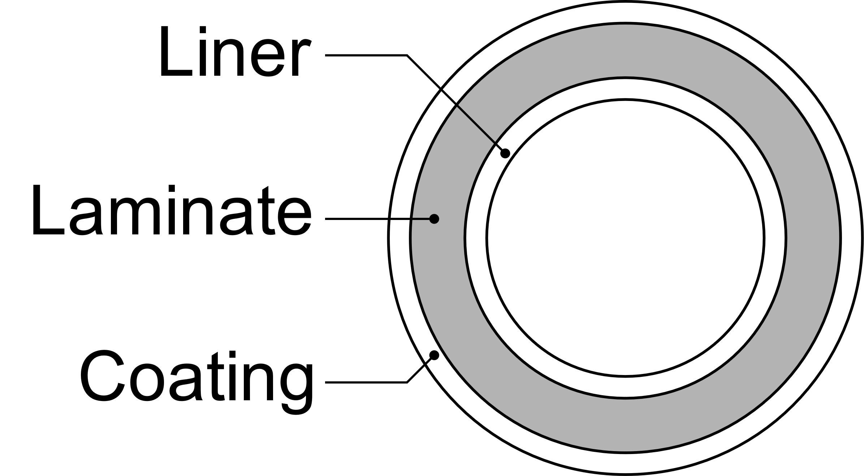

The temperature transient analysis is performed by solving the heat equation in cylindrical coordinates. The effects of the hydrocarbons are assessed using CheFem. To simplify the analysis, Toluene is used to represent the hydrocarbon mixture. This is conservative because Toluene has a faster diffusion and a larger impact on PVDF compared to typical production fluids.

### Result - Heat transient analysis

The results of the transient heat analysis are shown in Figure 1. The thermal equilibrium is reached faster than the duration of the thermal event because a flat temperature line can be seen during the event for all three layers. The maximum temperature encountered in the laminate is less than 64 °C. The TCP can sustain 130°C in these conditions because the structural layer is never beyond its current qualified capability. Qualified data is available for CF-PVDF at 93°C. The behaviour and performance of the material at 64 °C is well known and characterised.



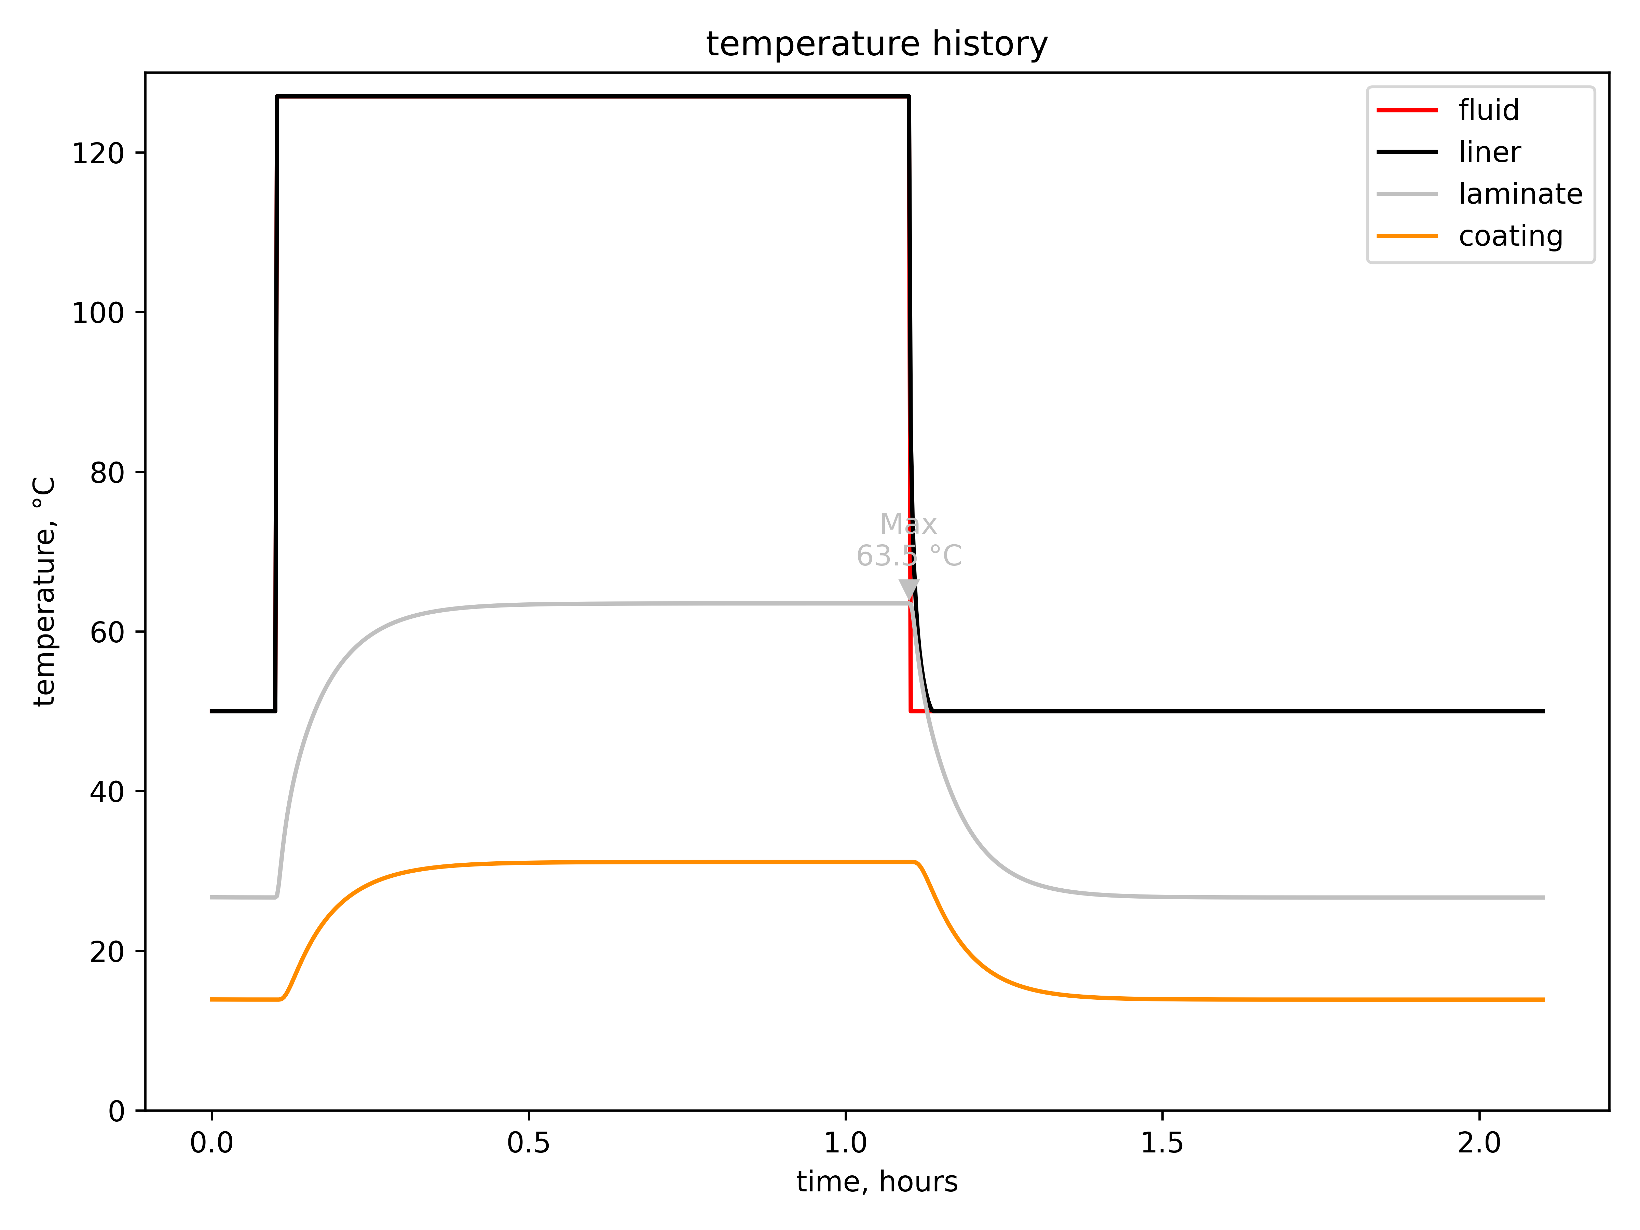

Figure 1: Maximum temperature calculated in each TCP layer during a blowdown event.

### Thermo-chemical analysis

A summary of the material assessment is shown in Table 1. Saturation with MEG produces a small temperature shift and uptake in line with the effects measured as part of Strohm material qualification. Saturation with Toluene has a stronger plasticization effect on the material with a larger mass uptake and temperature shift. However, the exposure to Toluene is very limited.

Table 1: CF-PVDF steady-state thermo-chemical assessment.

|  |  |  |  |  |  |  |  |  |  |  |
| --- | --- | --- | --- | --- | --- | --- | --- | --- | --- | --- |
| **Material** | **Fluid** | **Liner** | | | **Laminate** | | | **Coating** | | |
| **t-Shift**  **(°C)** | **Max Uptake (%)** | **Tlag**  **(days)** | **t-Shift**  **(°C)** | **Max Uptake (%)** | **Tlag**  **(yrs)** | **t-Shift**  **(°C)** | **Uptake**  **(%)** | **Tlag**  **(yrs)** |
| PVDF | MEG | 16 | 3.412 | 126 | 21 | 1.95 | 11 | 19 | 3.456 | 3 |
| PVDF | Toluene | 32 | 10.69 | 1 | 31 | 3.616 | 0.23 | 23 | 5.22 | 0.25 |

The saturation curves over a duration of 6 hours shows that the Toluene does not diffuse fast enough to affect the CF-PVDF laminate layer. This means that the material performance and behavior (strength and stiffness) are not affected by the transient exposure to Toluene.

Figure 2: Toluene saturation profiles over 6 hours.

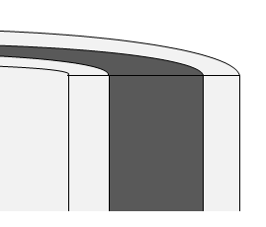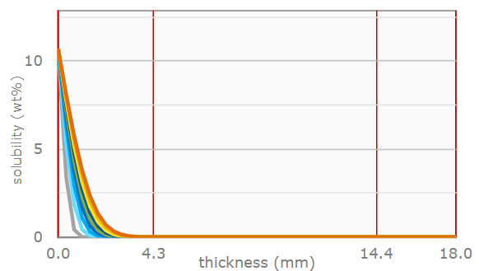

HC (Tolune) - Exposure (100% HC / 127 °C)

(3.9 mm ; 0%)

### Conclusions

First, the continuous case is verified against the current qualification envelope. MEG has a reduced impact on the performance of the material compared to the fluid used for the qualification.

The two following points are concluded from the transient assessment:

* The thermal analysis demonstrates that the laminate will not exceed 64 °C in temperature during the 130 °C temperature excursion.
* The chemical analysis shows that the 6 hours duration of the temperature excursion is not sufficient for aromatic hydrocarbons to diffuse through the liner and affect the laminate.

**The CF-PVDF TCP is therefore fit-for-purpose for the target application and the performance of the laminate is well within the current qualification envelope.**

API Technology Readiness Level

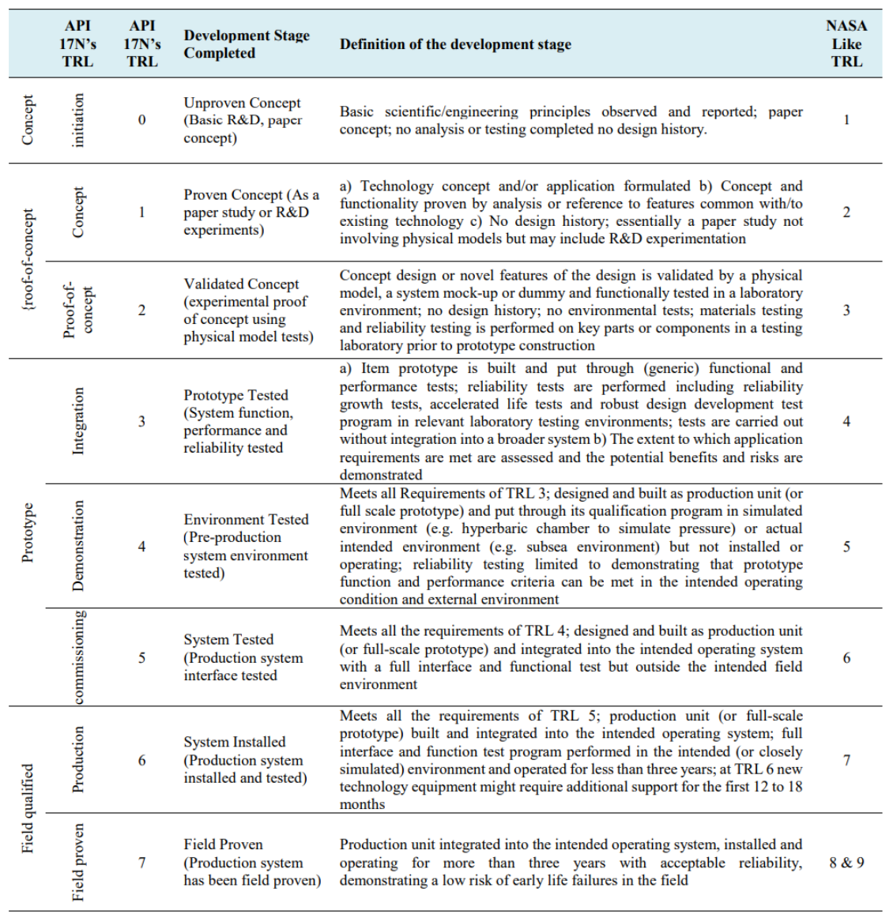

Manufacturing Readiness Level

